The Growing Confidence Project
Youth Worker

JOB DESCRIPTION
Accountable to: Senior Youth Worker
Responsible for: Young people

Objective of the job
To prevent young people at risk from being excluded from school, to re-engage them with education and support them into the workplace by inspiring them using the natural environment.

About the Role
Your role is to work with primarily school-aged young people who do not thrive in an academic environment. By working here at Fordhall with these young people you will change the lives of these individuals for the better. You will empower young people and give them new opportunities. Our support enables participants to make choices about their present and future options, regarding education, careers, and social situations.

By working with the same young people each week you will get to know them; you will gain their trust and you will work together to achieve practical tasks on the farm, whilst simultaneously building their confidence and self-belief. The activities that you develop and run will involve conservation work, community work, green woodwork and general farm maintenance.

You will liaise with the schools and establishments referring the young people, working with them to achieve the best results for each young person. You will also work closely with Growing Confidence partners to share skills and experience and to refer suitable participants to further their achievements.

During school holidays when not working directly on the Youth Project, you will deliver family and youth events.

Your days will be diverse and no two will ever be the same!

About You
You will need to be enthusiastic about enabling people and able to advocate on behalf of vulnerable people. Above all you will need to be passionate about helping young people fulfil their potential. You will have experience of working with challenging young people, demonstrating a supporting and nurturing approach. You will also work discreetly and in confidence where appropriate.

Flexibility is essential and you must be willing to undertake practical, purposeful activities in an outdoor environment in all weathers. You will be able to motivate and inspire those around you. Above all, you should have a genuine interest in the aims and ambitions of the Fordhall Community Land Initiative.
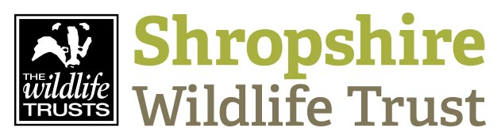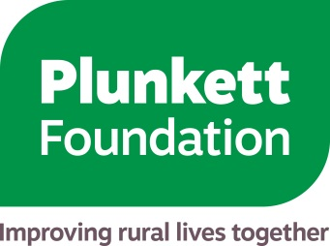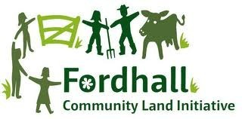

Key results expected
- Young people gain new skills, have increased knowledge of the natural environment and most importantly increased self-esteem and confidence.
- Habitats, access and interpretation will be improved at Fordhall Farm and other key sites, including Shropshire Wildlife Trust reserves.
- Young people achieve AQA Unit Awards in various skills
- Young people are reconnected with school and/or move into employment post education where appropriate.

Key tasks

Youth Work
- Plan and deliver the Youth Project, working with 2-3 young people per session to achieve the above outcomes.
- Act as an advocate for participants, developing their own interests and passions.
- Assist in the management and administration of the Youth Project and resources.
- Assess the needs of young people, continually amending your strategy to match their needs.
- Complete and adhere to risk assessments for activities and sites.
- Mentor, coach and support individuals to facilitate personal, social and educational growth.
- Plan and deliver youth events during school holidays
- Maintain an up-to-date knowledge of safeguarding, health & safety and local policy.
- Work with parents and referral organisations such as schools and children’s homes and provide daily sessional reports.
- Identify and pursue sources of funding for projects to improve services and/or resources for young people at Fordhall Farm.
- Provide regular updates and written reports on project progress for the partnership.
- Evaluate the progress of participants in line with guidance from Our Bright Future.
- Assist with promotion of the project through the press, organisation newsletter and social media posts.
- Support the project partnership to ensure all activities are fully integrated.

Miscellaneous
- Provide support for regular annual events at Fordhall including but not limited too, the annual Spring Fayre, the Bioblitz etc

For an informal discussion please call 01630 638696 and ask for Wendy Murray

To apply for this post complete the application form and return with a covering letter to: wendy.murray@fordhallfarm.com

The Growing Confidence Project
Person Specification: Youth Worker

CRITERIA | ESSENTIAL | DESIRABLE
QUALIFICATIONS  AND TRAINING | - A relevant qualification in youth/community work/social services work in the 11-25 age range | - A counselling accreditation or similar  - Qualifications in conservation management  - First Aid Qualification  - Quad Bike training
PREVIOUS EXPERIENCE | - 2 years experience working with young people with SEND | - Planning and delivering events for 11-25 year olds  - Working on funded projects
KNOWLEDGE | - Understanding of farm work and habitat management  - A working understanding of safeguarding children and young people  - Working knowledge of health and safety in an outdoor environment | - A working knowledge of qualifications such as AQA Unit Awards and the John Muir Award  - Working knowledge of hand tools
SKILLS | - Ability to quickly build constructive and positive relationships with young people in groups and on an individual basis  - Excellent interpersonal skills including verbal and written communication skills.  - Proficient in using IT including the use of Microsoft Office  - Experience of working with marginalised/’hard to reach’ young people especially within a motivational capacity | - Greenwood working skills  - Carpentry and woodwork skills  - Competent in a variety of practical estate work and habitat conservation tasks
PERSONAL ATTRIBUTES AND DISPOSITION | - Must have an ability to think on their feet and adapt quickly to any situation and deal with unexpected problems  - Friendly and positive disposition  - Positive approach to embracing challenge and change, open to experimenting, new ideas, reflective practice and working with partner organisations.

TERMS OF EMPLOYMENT

Salary: | £19,510 per annum pro rata + pension package
Hours: | 3 days/week
Pre-employment checks: | This post will require a satisfactory enhanced DBS check.
Contract | This is a fixed term contract, ending 31st March 2021.
Holidays: | 28 working days per annum pro rata including normal public holidays  Days in lieu are offered for each weekend day worked.
Pension: | A pension package will be offered with The People’s Pension
Start Date: | May 2019
Closing date: | Midnight 31st March 2019
Interview dates: | WC 8th April

