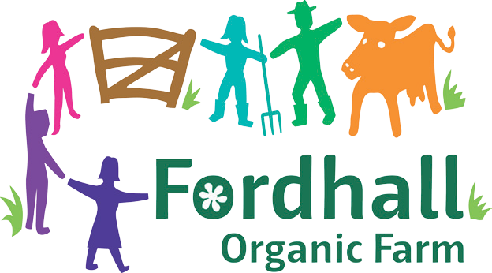

EXPRESSION OF WISHES FORM
Please print and complete this form and attach it to your Will, and if you are happy to please also send us a copy so we can also record your intentions following your passing. You can send it to Fordhall Community Land Initiative, Fordhall Organic Farm, Tern Hill Road, Market Drayton, Shropshire, TF9 3PS.

I, (insert your FULL name in capital letters) ……………………………..................................................................................

of (insert your address) ........................…………………………………...……………………………………………………………………

.....................…………………………………...…………………………………………Post Code: ……………………………………………….
am a shareholder in Fordhall Community Land Initiative Ltd (FCLI).

My Estate includes (insert number of shares) …. shares of £50 each in FCLI. I purchased these
shares not as an investment for personal gain but to support the work of this worthwhile charitable organisation.
I would like to express the wish that my shareholding in FCLI be;

 Converted to Fordhall Community Land Initiative as a donation.

 Repaid to my Estate
I understand that there is an optional administration charge of £10 for this. I am happy for you to deduct a £10 administration fee.  Yes  No

 Re-issued to the beneficiary named below who has expressed an interest in the continuing support of FCLI.

Name of beneficiary: …………………………………………………........................................................................................

Address of beneficiary: …………………………………………………………….….....................................................................

………………………………………………………………………………………………………………………Postcode: ……………………………….

Telephone no. ………………………... Email …………………………….…………………………………………………………………

Signature of shareholder: ..........................................

Date: ..........................

Please complete and return this completed document to: Fordhall Community Land Initiative, Fordhall Organic Farm, Tern Hill Road, Market Drayton, Shropshire, TF9 3PS.

You can also complete this form online at www.fordhallfarm.com/sharewishes

