Fordhall 2025 Calendar Photo Competition Entry Form

Guidelines/Terms and conditions (please read carefully):
- One entry per person.
- Only digital entries will be accepted – we will be unable to include hard copies in the competition.
- Any photo entered must be 5mb or over, sharp and in focus.
- The photo must be your own and have been taken on the farm.
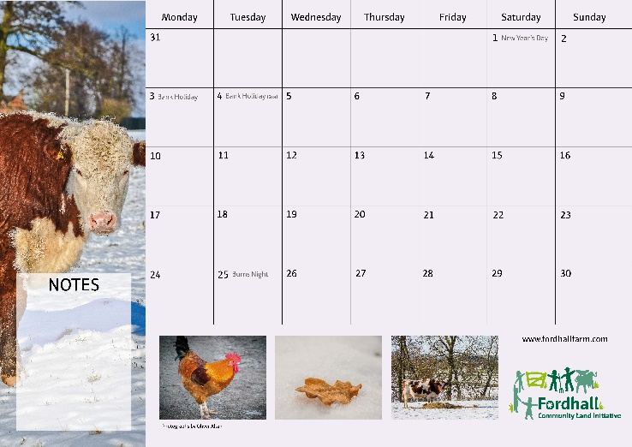
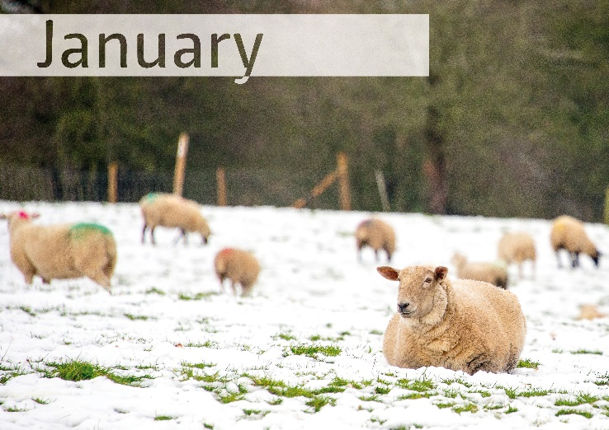
- Please note we cannot guarantee the winning picture will be a main calendar image – it may be a sidebar or small image (see example calendar month spread below).

- ALL parts of the form must be filled in and emailed with the photo to project@fordhallfarm.com
- Closing date: 31/08/2024
- Under 18s may enter but need parent/guardian permission to enter.
- By entering you are giving permission for your photo to be used for our own marketing purposes on our social media channels in the future.
- We may also post your entry to our social media channels prior to the closing date, as an interim ‘entries received so far’ post. Your full name will be published alongside this as credit.
- Prize: the one winning entry will be featured in the calendar (your full name will be published with this as credit, and announced on our social media channels – by entering you are confirming you consent to this), 1 x 2025 calendar to keep and 1 x £5 voucher to use on the farm.
Please delete/fill in the below answers as appropriate:
- I have read, understood and agree to the terms and conditions:
YES / NO

- If under 18, do you have parent/guardian permission to enter?
Yes / No / N/A

- Please provide:
  - Name:
  - Parent/Guardian name (if under 18):
  - Email address:
  - Phone number:
  - Postal address:

Thank you for your entry – good luck!

